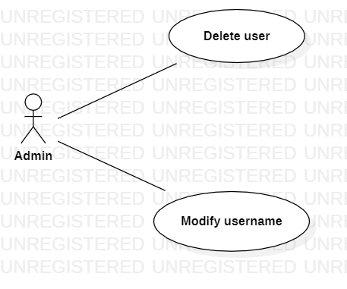

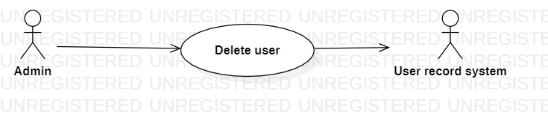

|  |  |
| --- | --- |
| **Delete user** | |
| Actors | Admin, user record system |
| Description | An admin send the username to the user record system with the command that delete this user from database |
| Data | username |
| Stimulus | Interface that including username and delete button |
| Response | Message that: delete successful or fail (kind of error) |
| Comments | Admin must have permission to delete user. Some system, they also keep the record but set a flag to show that this user is delete |